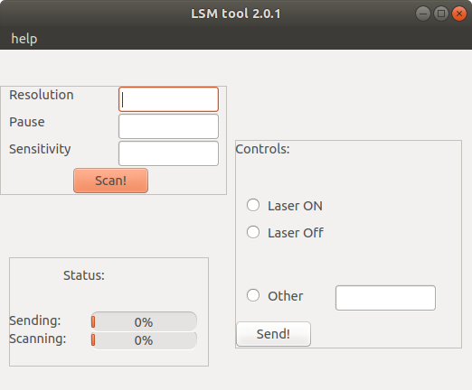
Progress bars
LSM controls

Scan controls

Help menu

Scan button!

Using LSM tool 2.0.1 is a piece of cake! All you need to do is type in the following details and hit Scan!
- Resolution
  - This is the control for the scan resolution, but it is kind of backwards!
    - It is the number of the percent of the range of the microscope of “possible pixels” to skip, between 0 and 100, a larger value indicating a lower resolution, and a shorter scan time.
  - Keep in mind that this value is out of the 200 pixels in BOTH the X and Y directions.
- Pause
  - This is the number of “centiseconds” (seconds divided by one hundred) to wait in between each pixel.

